**Notepad++ Dark Theme** 

***Notepad++*** is one of the oldest software editors which ruled the editor world for few years before other editors like Visual Studio Code, Atom, Sublime text, etc came in the foreground with many new features giving a tough competition to ***Notepad++****.*

***Dark Theme*** improves the readability during the night without causing harm to your eyes. Someone once said, that all the cool kids are using a dark theme these days. So, let’s see how we can use ***dark themes*** in ***Notepad++***. 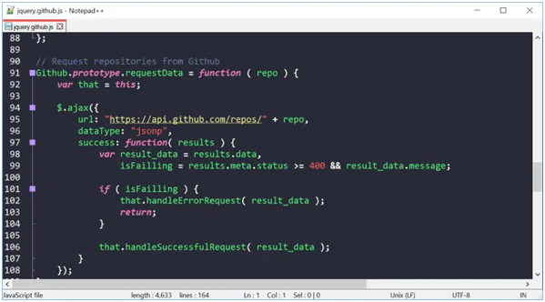

**How to enable Notepad++ Dark theme:**

**Steps to install a theme:**

You may require Admin access in Windows.

Step 1- Drag the XML file of the theme you want to use into your themes “C:\Program Files(x86)\Notepad++\Themes” folder. Earlier themes were located in the ***Notepad++*** installation folder but now in the updated version they’re located in the AppData folder:

“C:\Users\YOUR_USER\AppData\Roaming\Notepad++\themes”

Step 1.1- In Explorer, go to “%AppData%\Notepad++”.

Step 1.2- Check for folder “themes”, if it doesn’t exist, then create one.

Step 1.3- Download the themes, you want to use and drag them to the themes folder “%AppData%\Notepad++\themes”.

For example- You can download the Dracula Theme from here: <https://draculatheme.com/notepad-plus-plus>

Step 1.4- Restart Notepad++and then use “Settings -> Style Configurator”. The new themes will appear in the list.

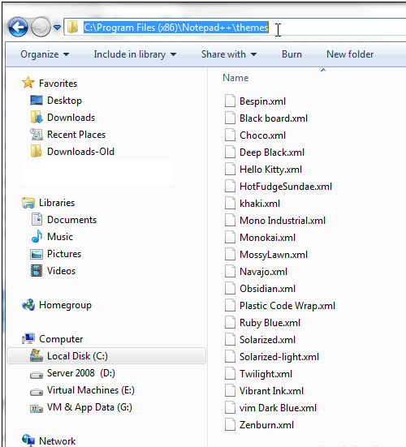

**How to select the new theme in Notepad preference:**

Step 1- Open ***Notepad++***, and pick “Settings” on the menu bar, and then pick “Style configurator”.

Step 2- Pick theme “Obsidian” (You’re free to pick other dark themes, the top two are easiest to read by most people’s preference)

Step 3- Move to “Global Styles”, and pick “Global override“, and then pick “background color” 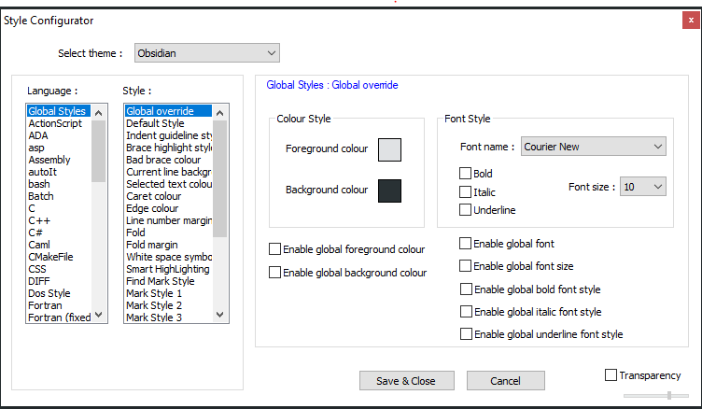

Step 4- Pick “more colors”, and then use any combination as per your wish for example you can use “red: 43, blue: 43, green: 43” i.e., (0*2B2B2B)

Step 5- Pick “Enable global background color” and check it.

There’re many ***dark themes*** that you can use like BlackBoard, Twilight, Vibrant Black, Plastic Code Wrap, etc. Enable any of them and enjoy working in night without straining your eyes.